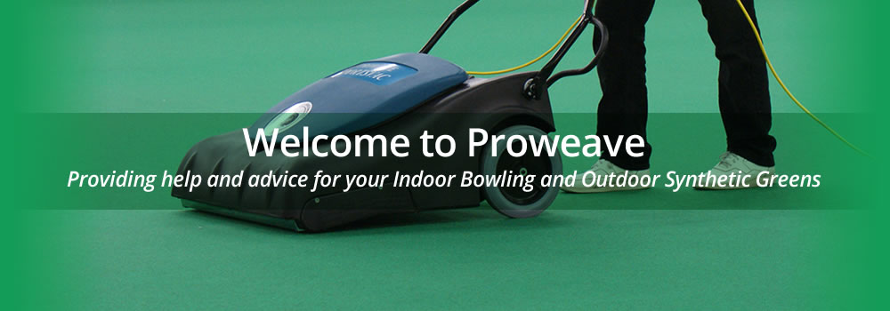
Synthetic Outdoor Greens
Introduction UK Version
Synthetic outdoor greens are becoming increasingly common as the costs of maintaining a grass playing surface continue to rise year on year. Many clubs therefore now see synthetic surfaces as the only way forward in giving their club long term viability as membership numbers in the sport of bowls continues to slowly drop around the world. It eradicates the high capital cost of machinery to prepare, cut, maintain and feed the playing surface together with trying to find, members to do this work. In areas of the country where they do not get much rain it removes the need for an irrigation system and of course the cost of water which seems to rise year on year. A synthetic surface gives clubs a lengthened outdoor season with all the increased revenue that it brings, and many clubs now play outdoor bowls all the year around. In the UK we have been relatively slow to adopt synthetic outdoor surfaces whilst in other parts of the bowls playing world where irrigation costs are far greater it has become the norm to play on synthetic.
All greens are subject to the harsh elements of the weather which depending on where you are in the world can be the sun, wind, rain, frost and snow or a combination of them all. The outdoor atmosphere at all times carries petro carbons, sand and dust; couple this with bird droppings, humidity and rain, and it can quickly provide an ideal germination environment for the summer and autumn invasion of spores, pollen and seeds which get caught up in the fibrous nature of the artificial playing surface.
Typically, maintenance in the past consisted of sweeping or blowing the green to remove surface debris and spraying the green on an annual or bi-annual basis with a moss killer. However synthetic greens need to be maintained much better if clubs wish to maximise the life expectancy of the playing surface and they need to adopt a regular cleaning regime where you vacuum the carpet at least once weekly especially during the summer and autumn months. Likewise moss killer certainly in the UK or Ireland should be applied twice yearly as an absolute minimum and if you are in an area that is prone to moisture and moss then three times a year would certainly be beneficial.
If allowed to germinate many of the plants are hard to remove; moss in particular is almost impossible because the plant becomes intertwined within the carpet structure. It can of course be sprayed to kill any future growth, but it is still almost impossible to remove without damage to the artificial surface itself. Build-up of moss in a synthetic green slows the bowl down as it does on a grass surface and can affect the natural line of the bowl. It also looks unsightly but more importantly prematurely ages the synthetic surface and can bring forward the cost of replacement by several years.
Moss
Moss is the biggest destroyer of bowling greens in the British Isles due to the temperate climate that we have and in the last few decades the winters have been much warmer and wetter. This creates an ideal environment for moss to develop and clubs that do not have in place a maintenance program can very quickly see their green ruined by this very invasive species.
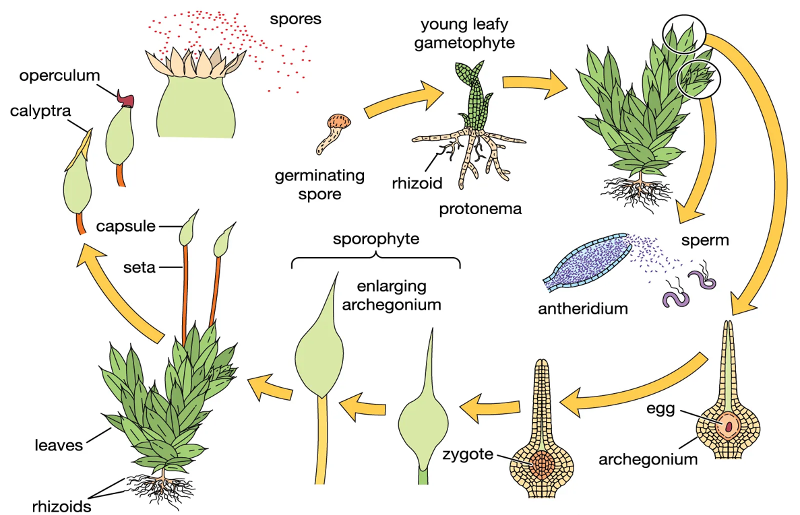

The above picture shows the eight stages of the life cycle of moss. The important thing is to try and prevent stage one which is the moss spore from germinating and becoming a young leafy gametophyte. The only way to achieve some control over germination is to use a Proweave Sportsvac on a regular basis and only when the green is dry enough. The problem we have is that moss spores are invisible to the human eye and can only be seen using a high powered microscope. The pictures below show a laden moss spore head, the release of thousands of spores and the spores which cannot be seen on the green but need to be removed from the bowls surface before they get chance to germinate.
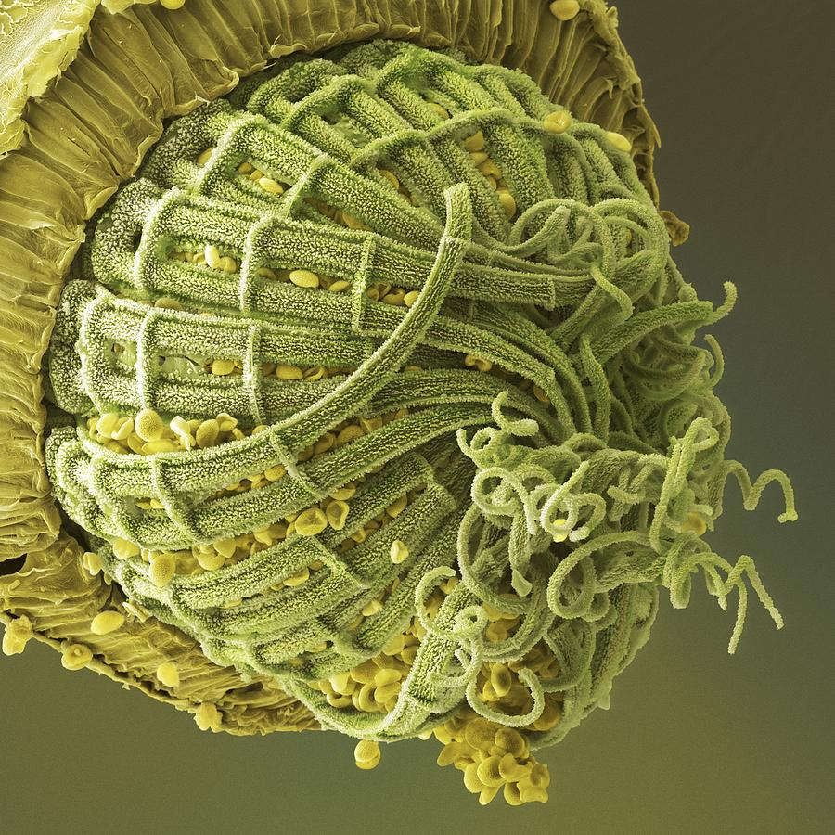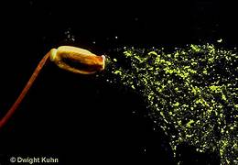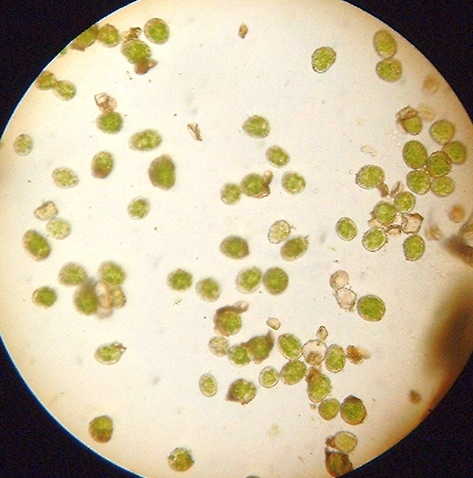
Moss Spore Head Release of Spores Spores under a microscope
Moss is part of the rhizoid plant family and as such uses its root system as an anchoring point rather than feeding the plant with nutrition and water. If it can attach itself to Cornish granite, it has absolutely no problem with an outdoor synthetic bowls carpet. Once the plant becomes established it sends out a horizontal rhizome which forms into another tap root and the bowls carpet becomes increasingly affected.
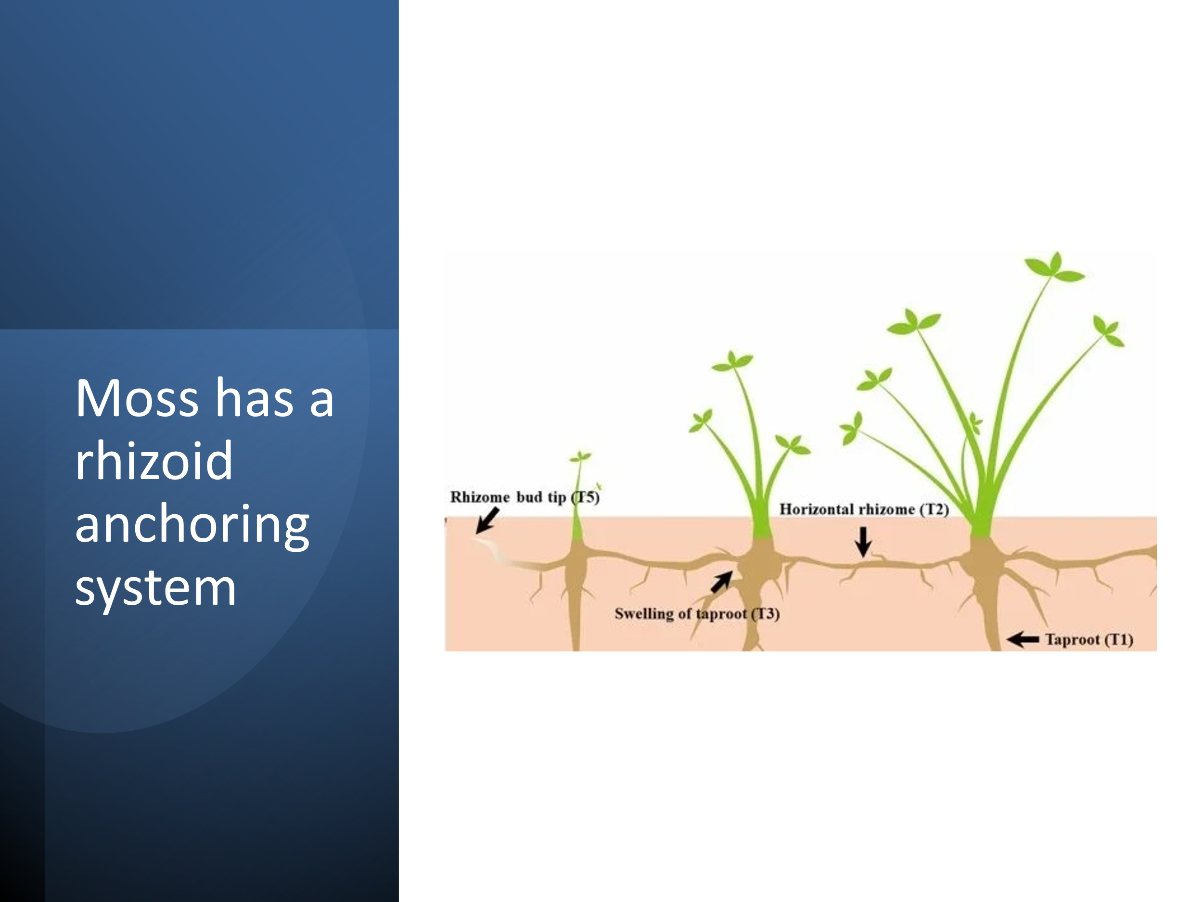
The two pictures below show synthetic greens where maintenance has been low on the priority list, or perhaps not even on the radar of the clubs concerned.
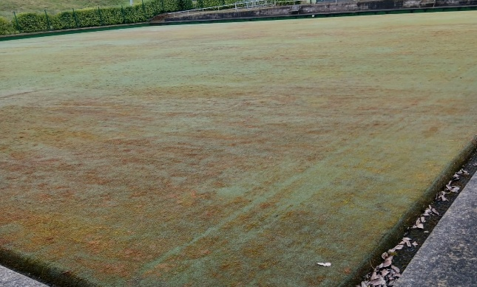 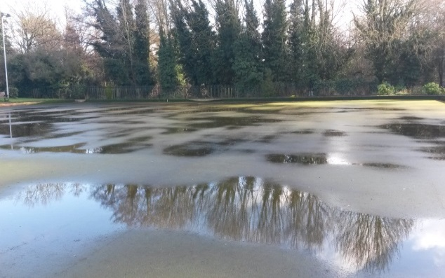
The build up of moss if left unchecked After rainfall the green will not drain
To prevent your green becoming like the pictures above you need to remove these spores so that you reduce the risk of germination. The best way to do this is to using an industrial vacuum cleaner such as a Proweave Sportsvac . This vacuum cleaner has been supplied to over 100 clubs who have a synthetic outdoor and a full listing can be seen by going to the website www.proweavesportsvac.com and clicking on to the 'Existing Users' header. This vacuum cleaner will remove the majority of surface debris but more importantly remove the unseen moss and fungal spores and prevent them from germinating. It is therefore important to vacuum the green on a regular basis even when it may appear that the green looks clean and tidy. Please note however that the vacuum is a dry only vacuum and should not be used in damp or wet conditions. 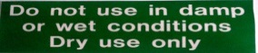
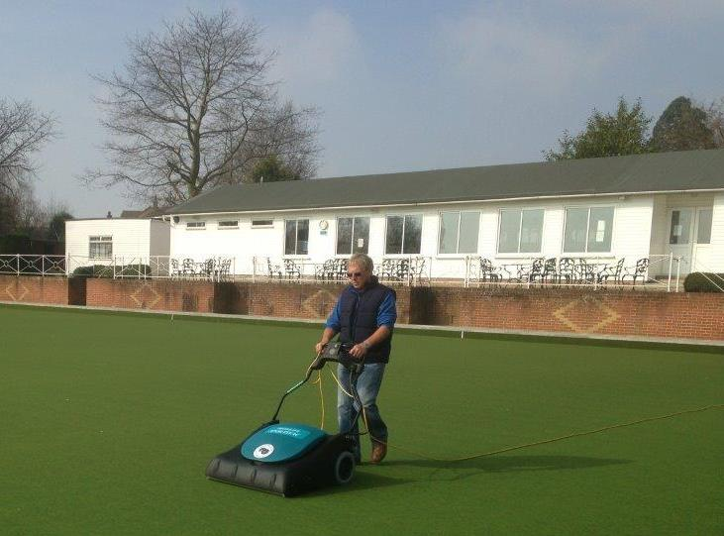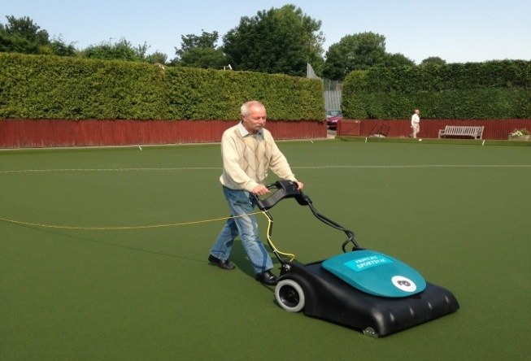
Moss likes a moist environment, and the dampest part of the green will of course be the ditches. These need to be kept clean of weeds, leaf litter and moss before it has chance to mature and send its thousands of spores into the atmosphere and onto the surface of the green where it may germinate again.
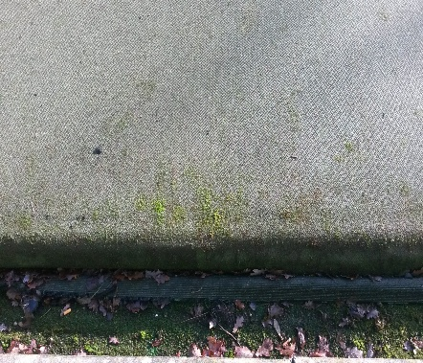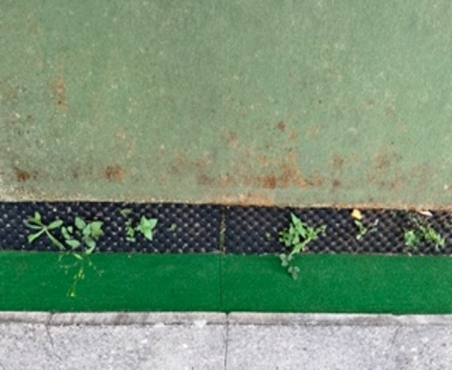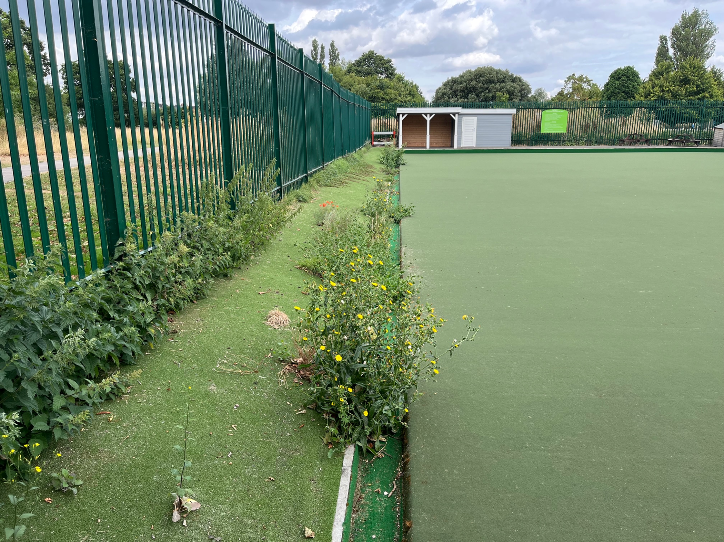
With climate change being as it is in the UK we are having much wetter and milder winters which gives greater opportunity for moss to develop in the playing surface. Greens need to be sprayed for moss at least two times a year in the areas on the map in pale blue and possibly three times a year if your club is in the purple or lilac areas in the map below.
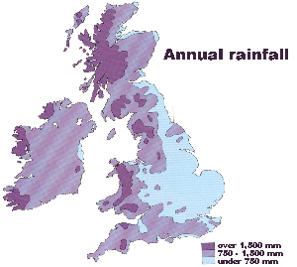
The Proweave Sportsvac is your first line of defence against moss and will help to control the amount of spores germinating by removing them from the green. Once you see any sign of moss germinating whether it be on the green or the ditches, it should be treated with a moss killer either in the area affected with a knapsack sprayer or if doing the entire green using preferably a straight line sprayer like the one below. 5 litres of moss killer treats about 500 square metres so you will need about 15 litres for a six rink green. Once treated the moss should brown off within a few days and become brittle enabling the the brushes of the vacuum cleaner to remove any surface moss. If however you have an area that is more established you may find using a medium broom or a Turfmatic Agitator or something similar.
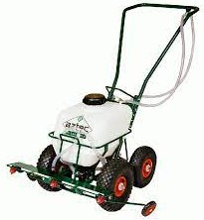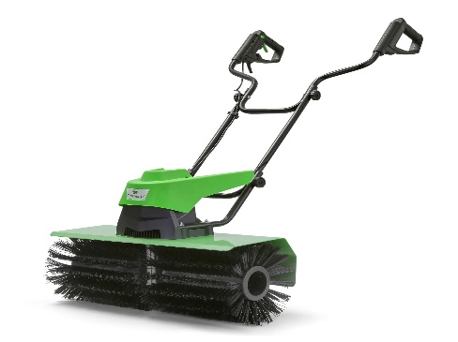
Aztec Straight Line 4 Jet Sprayer Turfmatic Agitator
The Turfmatic Agitator which is in use with Erdington BC in Warwickshire who have a Dales Mastergreen surface is also very good at removing bird guano should your club be pestered by gulls or pigeons or even worse overflying geese.
Another option as an alternative to using moss killer is the use of Bio Washing Powder. Bromyard BC in Herefordshire use this and they find it very effective in killing the moss plus as it works its way through the carpet, it cleans it and improves the drainage. This is applied directly onto the green in powder form using a spreader and is applied just before they know a wet spell of weather is coming through and rely on mother nature to wash it through the carpet. I have seen the effect of this on their carpet and since they have been using this system the moss has been removed and the green looks amazing given that it is now 12 years old.
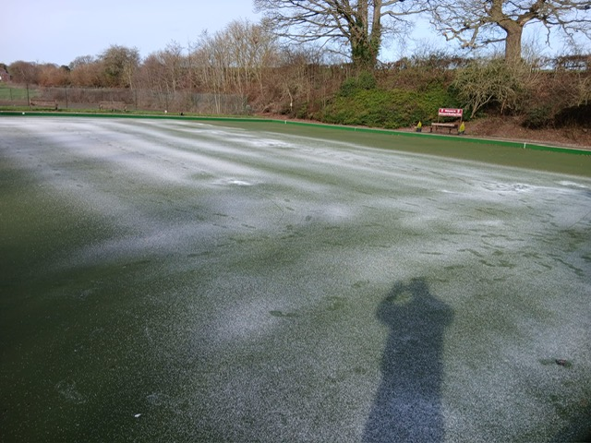
The good thing about this system is that you can do just a couple of rinks at a time so that the green does not have to be closed. If you would like to know more about this please contact Marcus Smith from Bromyard who will be only too pleased to speak to you about this (Mobile 07531249983 )

